EWMA correlation: USDCHF and USDCAD
Method 06 / daily log returns / lambda = 0.94 / Alpari D1 full available history

Study setup
Logical pair: USDCHF , USDCAD
Broker symbols: USDCHF_i , USDCAD_i
Snapshot: 2026-11-03_majors_alpari_D1
Timeframe: D1
Matched return window: 1999-01-05 to 2026-11-02 (UTC bar dates)
Matched return count n: 7188
Dropped unfinished last bar dated 2026-11-03 UTC after a tick-volume check against the prior complete day.
Lambda: 0.94 (today weight 0.06)
Burn-in ignored in path summaries and chart: first 60 updates
Mean adjustment: each leg demeaned by its mean on the matched rows
Seeds: c_0 = v_x,0 = v_y,0 = 0
Complete matched rows (Excel): USDCHF-USDCAD_EWMA_D1.xlsx
Complete matched rows (HTML table): USDCHF-USDCAD_EWMA_D1_data.html

Method carried forward
EWMA correlation updates covariance and variances of mean-adjusted daily log returns of close, ln(close_t / close_t-1), with lambda = 0.94 (6% weight on today's product or square, 94% on yesterday's EWMA state). Quotes are not inverted. Each leg is demeaned by its mean on the matched rows; that mean uses the full sample, so the rho path is a full-sample description, not a live filter. Seeds start at zero. Path summaries and the chart ignore the first 60 updates so the zero seed has faded. The headline is rho on the last day. rho is symmetric under swap of the two symbols. A high |rho| does not prove cause, lead-lag, or a trading signal. Today's return sits inside today's rho, so the estimate can only inform a later decision. Same-sample Pearson r is a side check only.

Results
Latest EWMA rho: 0.480567
Post-burn-in path (n=7128): mean=0.338190, median=0.368459, min=-0.522730, max=0.852657, std=0.245171
Share of post-burn-in days with |rho| >= 0.4: 44.89%; |rho| >= 0.7: 4.63%
Same-sample Pearson r: 0.304665
Latest rho minus r: 0.175902

Conclusion
Over 7188 matched daily log-return rows for USDCHF and USDCAD (broker quote directions unchanged), latest EWMA rho with lambda=0.94 is 0.4806 (positive, moderate recent linear link in this sample). After a 60-day burn-in, path mean is 0.3382, std is 0.2452, and the range is [-0.5227, 0.8527]. Same-sample Pearson r is 0.3047 (latest rho minus r = 0.1759). This does not establish cause, lead-lag, or a lasting trading rule.

Charts
Daily closes

Daily log returns
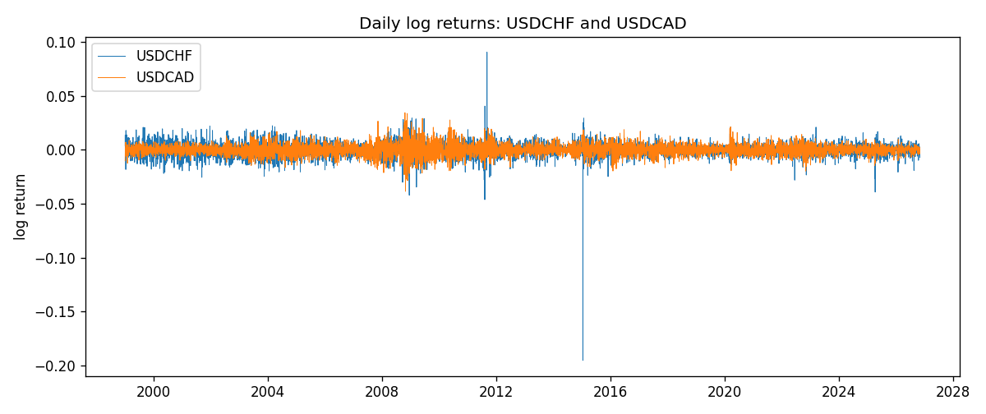
EWMA rho path with Pearson r reference
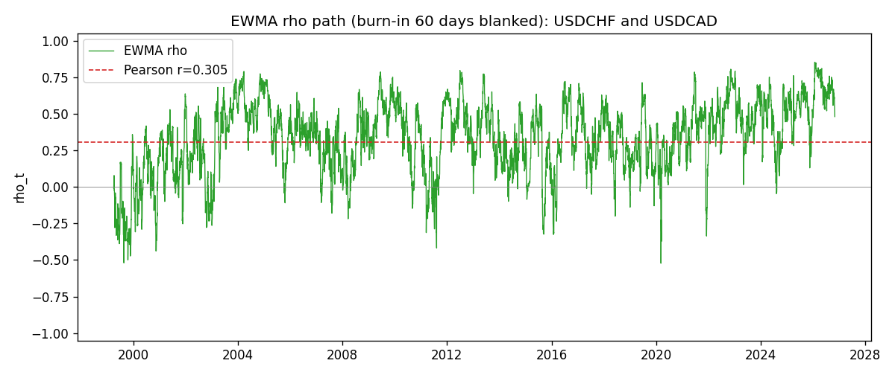

Data report
Every matched row that entered the EWMA recursion is stored in the sibling Excel workbook named USDCHF-USDCAD_EWMA_D1.xlsx. That file is the complete data archive for redrawing charts. Embedding all rows as a Word table is impractical at this length; the Word file holds the column list, column summaries, and the first and last 15 matched rows.
Columns: time, USDCHF_open, USDCAD_open, USDCHF_high, USDCAD_high, USDCHF_low, USDCAD_low, USDCHF_close, USDCAD_close, USDCHF_tick_volume, USDCAD_tick_volume, USDCHF_spread, USDCAD_spread, USDCHF_real_volume, USDCAD_real_volume, USDCHF_log_return, USDCAD_log_return, USDCHF_x_demeaned, USDCAD_y_demeaned, c_t, v_x, v_y, rho_t
Column summaries (matched calculation rows)
column | count | mean | std | min | 25% | 50% | 75% | max
USDCHF_open | 7188 | 1.0975966 | 0.25229688 | 0.72022 | 0.9205375 | 0.989955 | 1.2378 | 1.8219
USDCAD_open | 7188 | 1.2667824 | 0.16892678 | 0.9168 | 1.1183975 | 1.298465 | 1.3720475 | 1.6183
USDCHF_high | 7188 | 1.1028875 | 0.2540352 | 0.73305 | 0.924845 | 0.993545 | 1.242375 | 1.8313
USDCAD_high | 7188 | 1.2716804 | 0.16888565 | 0.9336 | 1.12285 | 1.30387 | 1.37646 | 1.619
USDCHF_low | 7188 | 1.0924772 | 0.25071604 | 0.08565 | 0.91725 | 0.9863 | 1.23155 | 1.8121
USDCAD_low | 7188 | 1.2622243 | 0.16896256 | 0.9056 | 1.114065 | 1.293535 | 1.3677775 | 1.6102
USDCHF_close | 7188 | 1.0975873 | 0.25219296 | 0.72025 | 0.920805 | 0.98995 | 1.2379 | 1.8217
USDCAD_close | 7188 | 1.2667976 | 0.16890032 | 0.916 | 1.118075 | 1.29844 | 1.372365 | 1.6137
USDCHF_tick_volume | 7188 | 74305.244 | 113479.97 | 1 | 12787.25 | 40220 | 70419.75 | 858589
USDCAD_tick_volume | 7188 | 81017.898 | 147302.44 | 1 | 5560 | 40941.5 | 71627 | 1410818
USDCHF_spread | 7188 | 26.050501 | 24.7086 | 0 | 5 | 16 | 50 | 100
USDCAD_spread | 7188 | 23.4399 | 18.261108 | 0 | 9 | 17 | 40 | 60
USDCHF_real_volume | 7188 | 2.3284369e+10 | 8.9116261e+10 | 0 | 0 | 0 | 0 | 1.9331921e+12
USDCAD_real_volume | 7188 | 1.8376704e+10 | 9.6688094e+10 | 0 | 0 | 0 | 0 | 2.5751613e+12
USDCHF_log_return | 7188 | -7.133e-05 | 0.00659527 | -0.19545699 | -0.0033544 | 8.077e-05 | 0.00332477 | 0.09051364
USDCAD_log_return | 7188 | -1.556e-05 | 0.00514382 | -0.03859748 | -0.00283746 | 4.44e-05 | 0.00272629 | 0.03436319
USDCHF_x_demeaned | 7188 | -0 | 0.00659527 | -0.19538566 | -0.00328307 | 0.0001521 | 0.0033961 | 0.09058497
USDCAD_y_demeaned | 7188 | -0 | 0.00514382 | -0.03858192 | -0.0028219 | 5.996e-05 | 0.00274185 | 0.03437875
c_t | 7188 | 1.032e-05 | 1.3e-05 | -3.179e-05 | 3.26e-06 | 7.17e-06 | 1.364e-05 | 0.00012583
v_x | 7188 | 4.346e-05 | 9.019e-05 | 9.7e-07 | 1.84e-05 | 2.965e-05 | 4.763e-05 | 0.00231223
v_y | 7188 | 2.644e-05 | 3.123e-05 | 3.69e-06 | 1.17e-05 | 1.801e-05 | 2.901e-05 | 0.00040857
rho_t | 7188 | 0.3327484 | 0.25220255 | -1 | 0.17984088 | 0.36626326 | 0.51858492 | 0.85265686
First 15 matched rows (selected columns)
time | USDCHF_close | USDCAD_close | USDCHF_log_return | USDCAD_log_return | USDCHF_x_demeaned | USDCAD_y_demeaned | c_t | v_x | v_y | rho_t
1999-01-05 | 1.3724 | 1.5123 | 0.0039424743 | -0.010131666 | 0.0040138007 | -0.010116107 | -2.4362423e-06 | 9.6663575e-07 | 6.1401374e-06 | -1
1999-01-06 | 1.3912 | 1.5118 | 0.013605652 | -0.0003306769 | 0.013676978 | -0.00031511841 | -2.5486598e-06 | 1.2132222e-05 | 5.7776871e-06 | -0.30441404
1999-01-07 | 1.3782 | 1.5141 | -0.0093883841 | 0.0015202092 | -0.0093170577 | 0.0015357676 | -3.2542703e-06 | 1.6612743e-05 | 5.5725408e-06 | -0.33822549
1999-01-08 | 1.3935 | 1.511 | 0.011040268 | -0.0020495197 | 0.011111594 | -0.0020339613 | -4.4150473e-06 | 2.302403e-05 | 5.4864083e-06 | -0.39282636
1999-01-11 | 1.4009 | 1.5057 | 0.0052963193 | -0.0035137769 | 0.0053676457 | -0.0034982185 | -5.2767763e-06 | 2.3371285e-05 | 5.8914757e-06 | -0.44969218
1999-01-12 | 1.3872 | 1.5157 | -0.0098275602 | 0.0066194721 | -0.0097562338 | 0.0066350306 | -8.8441443e-06 | 2.7680054e-05 | 8.1794051e-06 | -0.58777552
1999-01-13 | 1.3621 | 1.5226 | -0.018259701 | 0.0045420214 | -0.018188374 | 0.0045575799 | -1.3287194e-05 | 4.5868268e-05 | 8.9349328e-06 | -0.6563439
1999-01-14 | 1.3588 | 1.5332 | -0.0024256692 | 0.0069376546 | -0.0023543428 | 0.0069532131 | -1.3472177e-05 | 4.3448748e-05 | 1.1299667e-05 | -0.60801784
1999-01-15 | 1.3834 | 1.5245 | 0.01794228 | -0.0056905671 | 0.018013606 | -0.0056750086 | -1.8797489e-05 | 6.0311224e-05 | 1.2554031e-05 | -0.68313914
1999-01-18 | 1.379 | 1.526 | -0.0031856384 | 0.00098344542 | -0.003114312 | 0.0009990039 | -1.7856312e-05 | 5.7274486e-05 | 1.1860669e-05 | -0.68510409
1999-01-19 | 1.3789 | 1.5302 | -7.2518946e-05 | 0.002748513 | -1.1925293e-06 | 0.0027640714 | -1.6785131e-05 | 5.3838017e-05 | 1.1607435e-05 | -0.67144753
1999-01-20 | 1.3889 | 1.5211 | 0.0072259871 | -0.0059646885 | 0.0072973135 | -0.00594913 | -1.8382783e-05 | 5.3802783e-05 | 1.3034517e-05 | -0.69416292
1999-01-21 | 1.3836 | 1.5146 | -0.0038232689 | -0.0042823796 | -0.0037519424 | -0.0042668212 | -1.6319284e-05 | 5.1419241e-05 | 1.3344792e-05 | -0.62299185
1999-01-22 | 1.3834 | 1.5184 | -0.0001445609 | 0.0025057712 | -7.323448e-05 | 0.0025213297 | -1.5351206e-05 | 4.8334408e-05 | 1.2925531e-05 | -0.61417212
1999-01-25 | 1.3868 | 1.5197 | 0.0024546976 | 0.00085579808 | 0.0025260241 | 0.00087135657 | -1.4298069e-05 | 4.5817191e-05 | 1.2195555e-05 | -0.60487048
Last 15 matched rows (selected columns)
time | USDCHF_close | USDCAD_close | USDCHF_log_return | USDCAD_log_return | USDCHF_x_demeaned | USDCAD_y_demeaned | c_t | v_x | v_y | rho_t
2026-10-13 | 0.83244 | 1.4214 | -0.0024955621 | -0.0046395653 | -0.0024242357 | -0.0046240068 | 5.7328361e-06 | 1.3296656e-05 | 7.2198454e-06 | 0.58510575
2026-10-14 | 0.83489 | 1.42356 | 0.0029388325 | 0.0015184751 | 0.0030101589 | 0.0015340336 | 5.665927e-06 | 1.304252e-05 | 6.9278502e-06 | 0.59606137
2026-10-15 | 0.82676 | 1.41843 | -0.0097855323 | -0.0036101503 | -0.0097142059 | -0.0035945918 | 7.4210877e-06 | 1.7921916e-05 | 7.2874447e-06 | 0.64936325
2026-10-16 | 0.82377 | 1.41357 | -0.0036230826 | -0.0034322068 | -0.0035517562 | -0.0034166483 | 7.7039286e-06 | 1.76035e-05 | 7.5506071e-06 | 0.66822359
2026-10-19 | 0.82677 | 1.41091 | 0.0036351779 | -0.0018835331 | 0.0037065044 | -0.0018679746 | 6.8262735e-06 | 1.737158e-05 | 7.3069304e-06 | 0.60589384
2026-10-20 | 0.8246 | 1.40569 | -0.0026281224 | -0.0037066008 | -0.002556796 | -0.0036910424 | 6.9829316e-06 | 1.6721518e-05 | 7.6859422e-06 | 0.6159584
2026-10-21 | 0.82427 | 1.4045 | -0.00040027413 | -0.00084691787 | -0.00032894772 | -0.00083135939 | 6.5803641e-06 | 1.5724719e-05 | 7.2662552e-06 | 0.61560644
2026-10-22 | 0.82032 | 1.40081 | -0.0048036381 | -0.0026307268 | -0.0047323117 | -0.0026151683 | 6.9280898e-06 | 1.6124922e-05 | 7.2406262e-06 | 0.64117507
2026-10-23 | 0.82497 | 1.40085 | 0.005652514 | 2.85545e-05 | 0.0057238404 | 4.4112984e-05 | 6.5275541e-06 | 1.7123168e-05 | 6.8063054e-06 | 0.60464812
2026-10-26 | 0.82649 | 1.40093 | 0.0018407959 | 5.7106554e-05 | 0.0019121224 | 7.2665038e-05 | 6.1442376e-06 | 1.6315151e-05 | 6.3982439e-06 | 0.60137042
2026-10-27 | 0.82865 | 1.40449 | 0.0026100526 | 0.0025379458 | 0.002681379 | 0.0025535043 | 6.1863981e-06 | 1.5767629e-05 | 6.4055723e-06 | 0.61556752
2026-10-28 | 0.82781 | 1.39911 | -0.0010142111 | -0.0038379274 | -0.0009428847 | -0.0038223689 | 6.0314574e-06 | 1.4874913e-05 | 6.8978682e-06 | 0.59543944
2026-10-29 | 0.82379 | 1.39895 | -0.0048680164 | -0.00011436495 | -0.00479669 | -9.8806469e-05 | 5.6980066e-06 | 1.5362913e-05 | 6.4845819e-06 | 0.57088046
2026-10-30 | 0.82438 | 1.39751 | 0.00071594559 | -0.0010298736 | 0.00078727201 | -0.0010143151 | 5.3082137e-06 | 1.4478326e-05 | 6.1572371e-06 | 0.56220705
2026-11-02 | 0.81851 | 1.39837 | -0.0071459744 | 0.00061519094 | -0.007074648 | 0.00063074943 | 4.721981e-06 | 1.6612665e-05 | 5.8116735e-06 | 0.48056704

